**Lesson Five: From Judea to Galilee**

**Retiring to Galilee (Matthew 4:12,17; Mark 1:14-15; Luke 3:19-20; 4:14-15; John 4:1-54)**

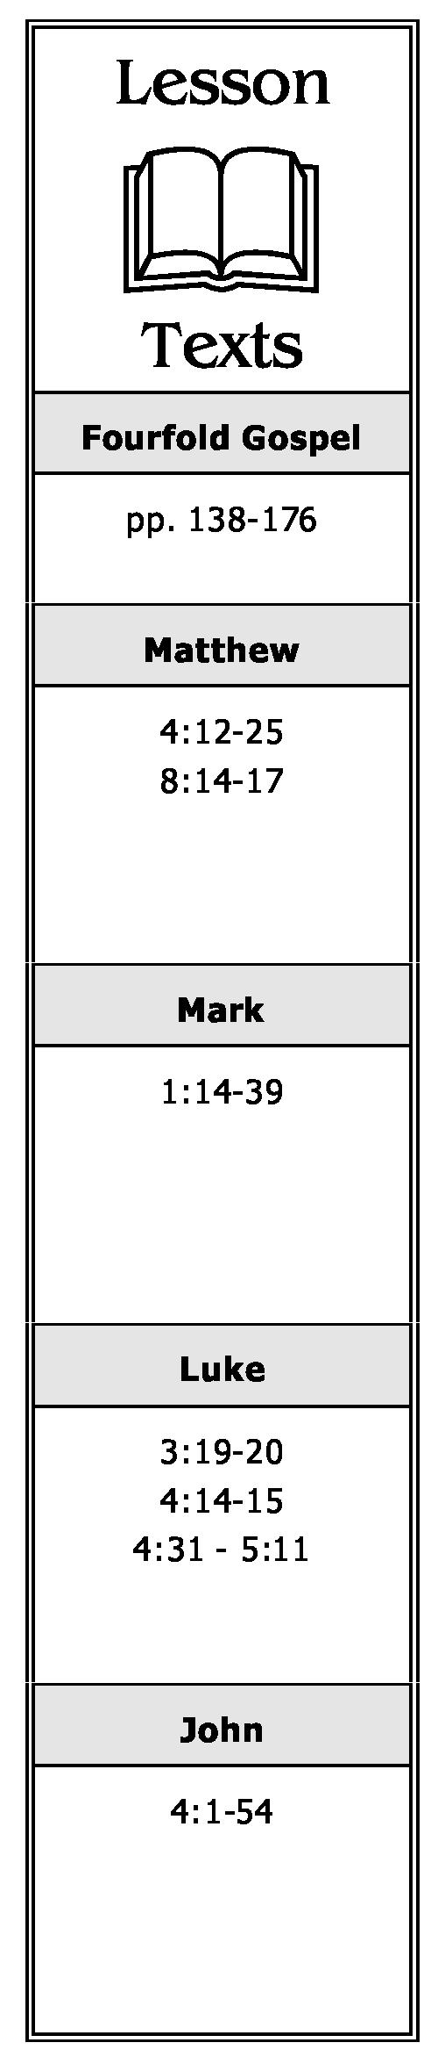

1. When Jesus heard that John the Baptist had been put in prison, where did He go?
2. Why had John been placed in prison?
3. What had the Pharisees heard concerning the results of Jesus' preaching? Why would that be important to them? To Jesus?
4. Why did Jesus go through Samaria on His way to Galilee?
5. Where did Jesus have a conversation with a Samaritan woman? Briefly describe this conversation and any conclusions we should draw from it and the events surrounding it.
6. What did Jesus tell His disciples His *"food (KJV: meat)"* was when they tried to get Him to eat?
7. Although the time for harvesting the grain fields was several months away, what did Jesus say to His disciples about the *"harvest?"* Explain.
8. Why did many of the Samaritans believe? Whose testimony was instrumental to their belief?
9. What did Jesus say in reference to a prophet having honor? Why? Where was He when He made this statement?
10. What did Jesus begin to preach upon His arrival in Galilee?

**A Chronological Study of the Life of Jesus Gene Taylor 16**

1. Briefly describe the second miracle Jesus performed at Cana of Galilee. What was the first?
2. While walking by the Sea of Galilee in Capernaum, who did Jesus call to follow Him? Briefly describe this incident.

**Preaching in Capernaum (Matthew 4:13-16, 18-25; 8:14-17; Mark 1:16-39; Luke 4:31-44; 5:1-11)**

1. Whose prophecy was fulfilled when Jesus left Nazareth and went to live in Capernaum?
2. What characteristic of Jesus' teaching astonished those who heard Him teach in the synagogue at Capernaum?
3. After an unclean spirit in a man at Capernaum recognized Him, what confession did he make concerning Jesus? What did Jesus say to this unclean spirit? What was the reaction of the people as a result of the unclean spirit obeying Jesus?
4. After leaving the synagogue in Capernaum, into whose house did Jesus go? Who did He find sick there? What did He do?
5. When Simon and others came to Jesus and told Him the people were seeking Him, what reason did He give for separating Himself from the multitudes who were seeking Him?
6. As Jesus traveled all over Galilee, what did He preach? What else did He do?
7. Where were the multitudes from who followed Jesus as a result of the miracles and teaching He had done during His travels in Galilee?

**A Chronological Study of the Life of Jesus Gene Taylor 17**